READ ME FILE
Welcome to this exciting Creative Multilingual Project – Children of the World! On this page you will find everything you need to prepare for the concert.
- Learning PowerPoints*
- Sing-a-long track with voice and piano
- Vocal/piano score
- Backing track without voice
- Word sheet
* Please note that the PowerPoint needs internet access in order to play some of the slides as some of the videos are stored on our YouTube Channel. You might see this message in which case you must click on Enable Content
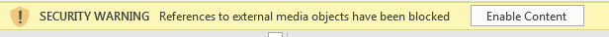
Or you might get this message:
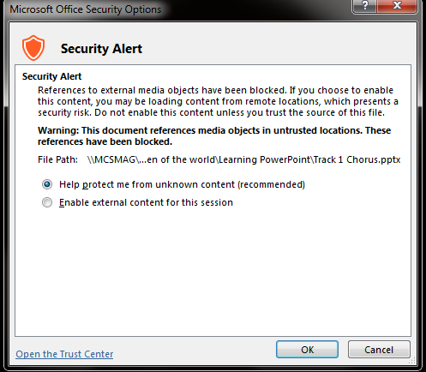
Again you must select Enable external content for this session in order for it to work.
If the internet is slow, then you might see a black screen:
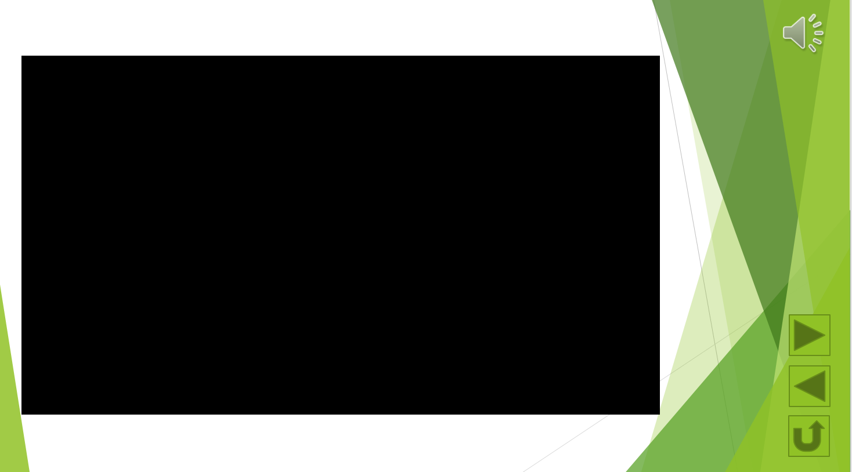
Be patient and wait for it to load. It should look like the one below and then click on the red play button in the middle:
